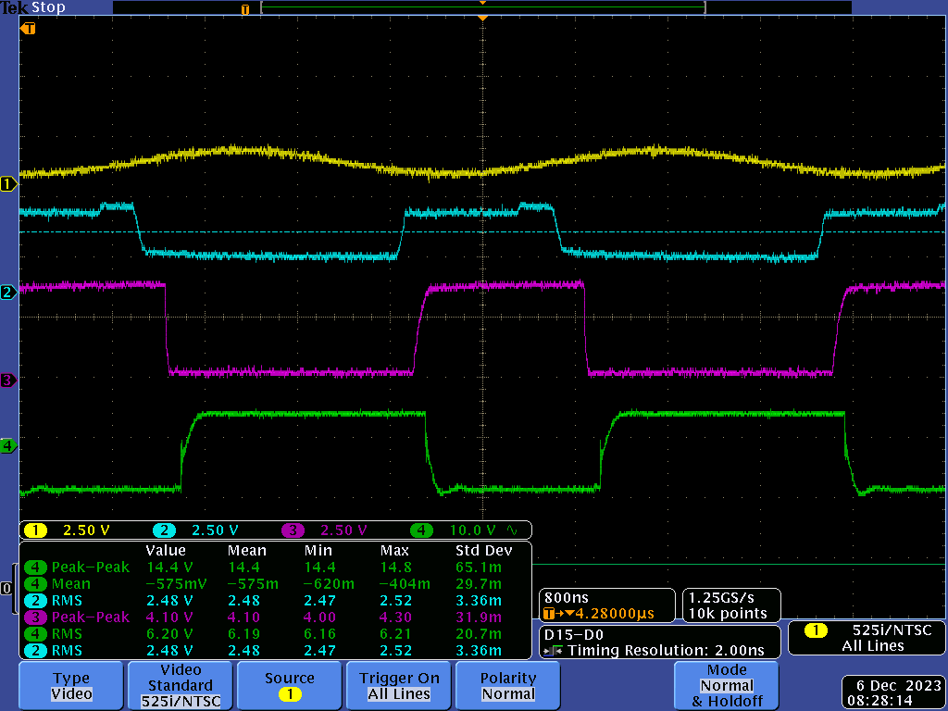

Yellow = ad9850 voltage output, blue = comparator, purple = opticoupler output, green = signal on high side gate

—------------------------------------------------

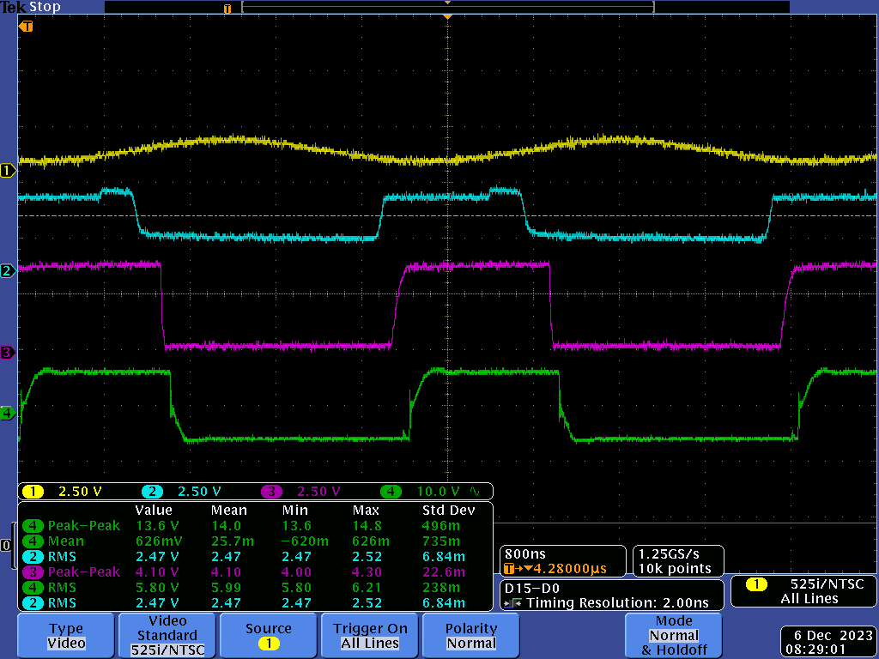

Yellow = ad9850 voltage output, blue = comparator, purple = opticoupler output, green = signal on low side gate

—--------------------------------------------

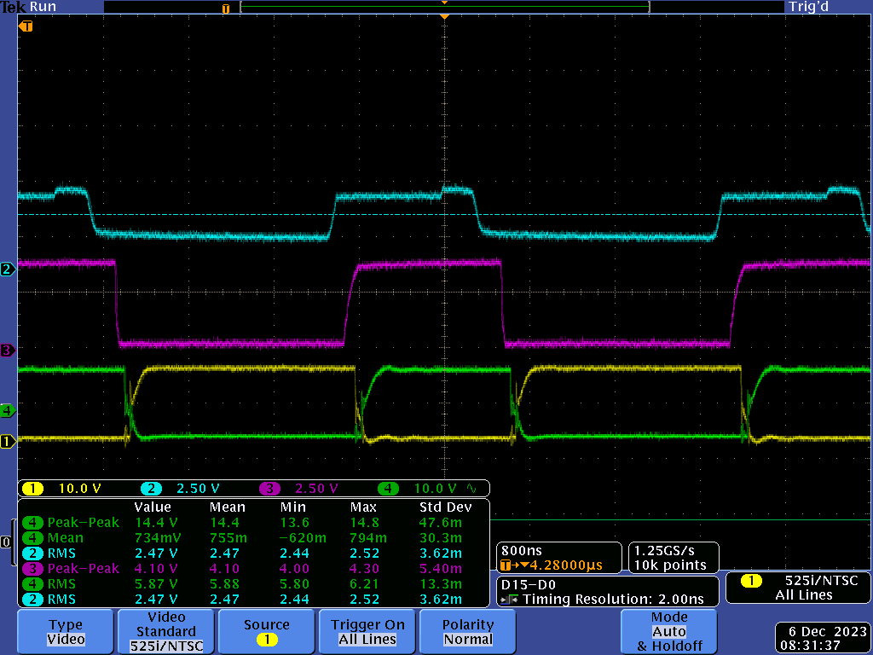

Blue = comparator, purple = opticoupler output, green = low side gate, yellow = high side gate

—-----------------------------

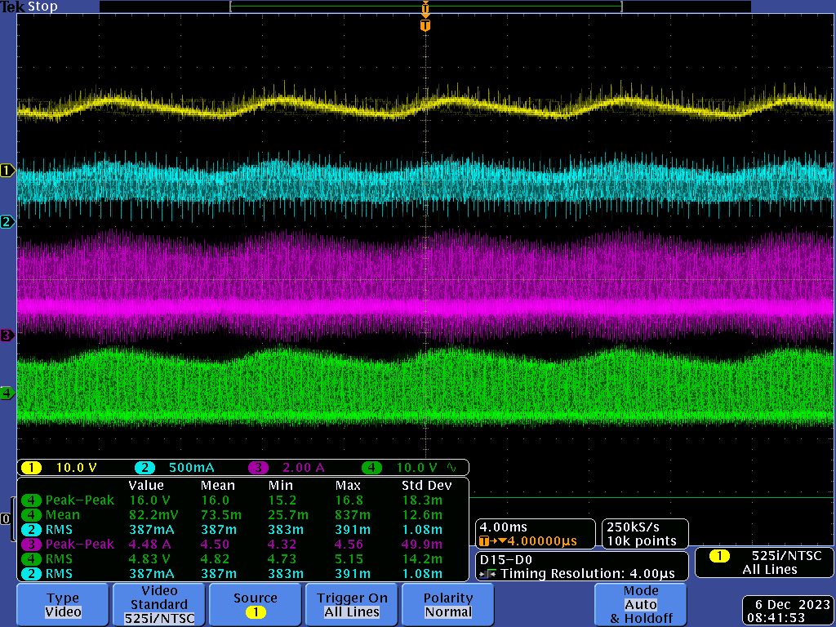

Yellow = DC bus voltage, blue = DC input current after electrolytic cap into switches, before 2 ceramic caps, purple = input current into the tank, green = voltage at tank input

—------------------------------------------------------------

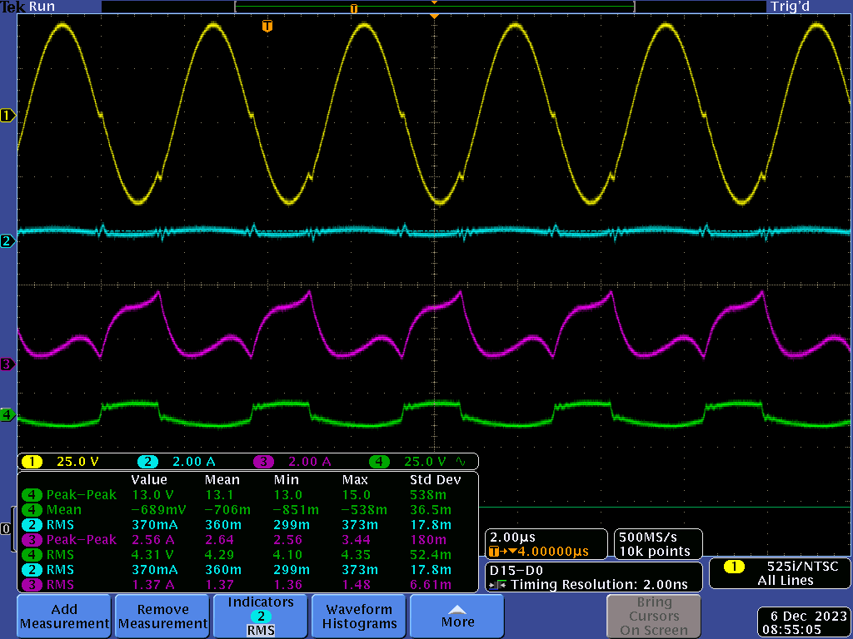

Yellow = primary winding voltage, blue = input current, purple = tank input current, green = tank input voltage

See that tank input vs output, large gain

RMS is 1.44A, RMS input current is 470mA